Ideation Phase
Brainstorm & Idea Prioritization Template

Date | 28 September 2026
Team ID | SWTID-2026-9290
Project Name | Askly – AI FAQ Assistant
Maximum Marks | 4 Marks

Brainstorm & Idea Prioritization Template:
Brainstorming provides a free and open environment that encourages everyone within a team to participate in the creative thinking process that leads to problem solving. Prioritizing volume over value, out-of-the-box ideas are welcome and built upon, and all participants are encouraged to collaborate, helping each other develop a rich amount of creative solutions.
Use this template in your own brainstorming sessions so your team can unleash their imagination and start shaping concepts even if you're not sitting in the same room.
Reference: https://www.mural.co/templates/brainstorm-and-idea-prioritization
Step-1: Team Gathering, Collaboration and Select the Problem Statement
Selected Problem Focus: Develop a simple AI FAQ Assistant that supports FAQ search and browsing, user authentication, FAQ creation and maintenance, and Gemini-assisted answer and FAQ generation.
Selected Problem Statement: Users often need quick answers to common questions, but manually creating, maintaining, and finding FAQ information can lead to repeated effort and inconsistent answers.
Team Members: Manju R, Keerthika R, Vagai Selvi E, Gopika K, Mahalakshmi M
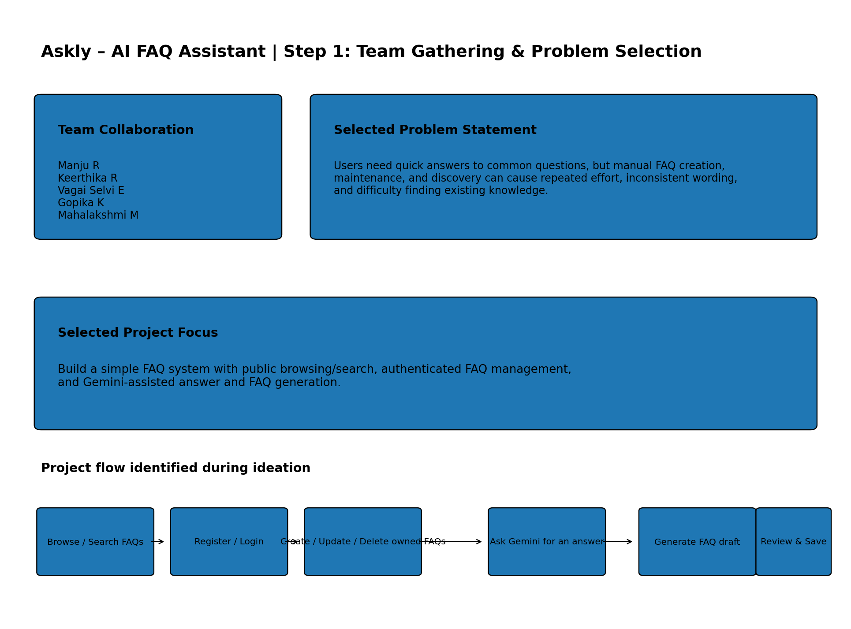

Step-2: Brainstorm, Idea Listing and Grouping
12. AI chat history / sessions — Future Extension — Priority: Low
11. Semantic/vector search — Future Extension — Priority: Low
10. Document upload and RAG search — Future Extension — Priority: Low
9. Question suggestions / auto-suggest — User Experience — Priority: Medium
8. Fallback/help message — User Experience — Priority: Medium
7. Creator-only edit and delete — Security — Priority: High
6. User registration and login — Authentication — Priority: High
5. Public FAQ browsing by category — Search / Discovery — Priority: High
4. Create, update and delete FAQs — FAQ Management — Priority: High
3. AI-generated FAQ question and answer pair — AI Authoring — Priority: High
2. AI-generated answer for a user question — AI Assistance — Priority: High
1. FAQ search by keyword — Search / Discovery — Priority: High
Brainstormed Ideas:
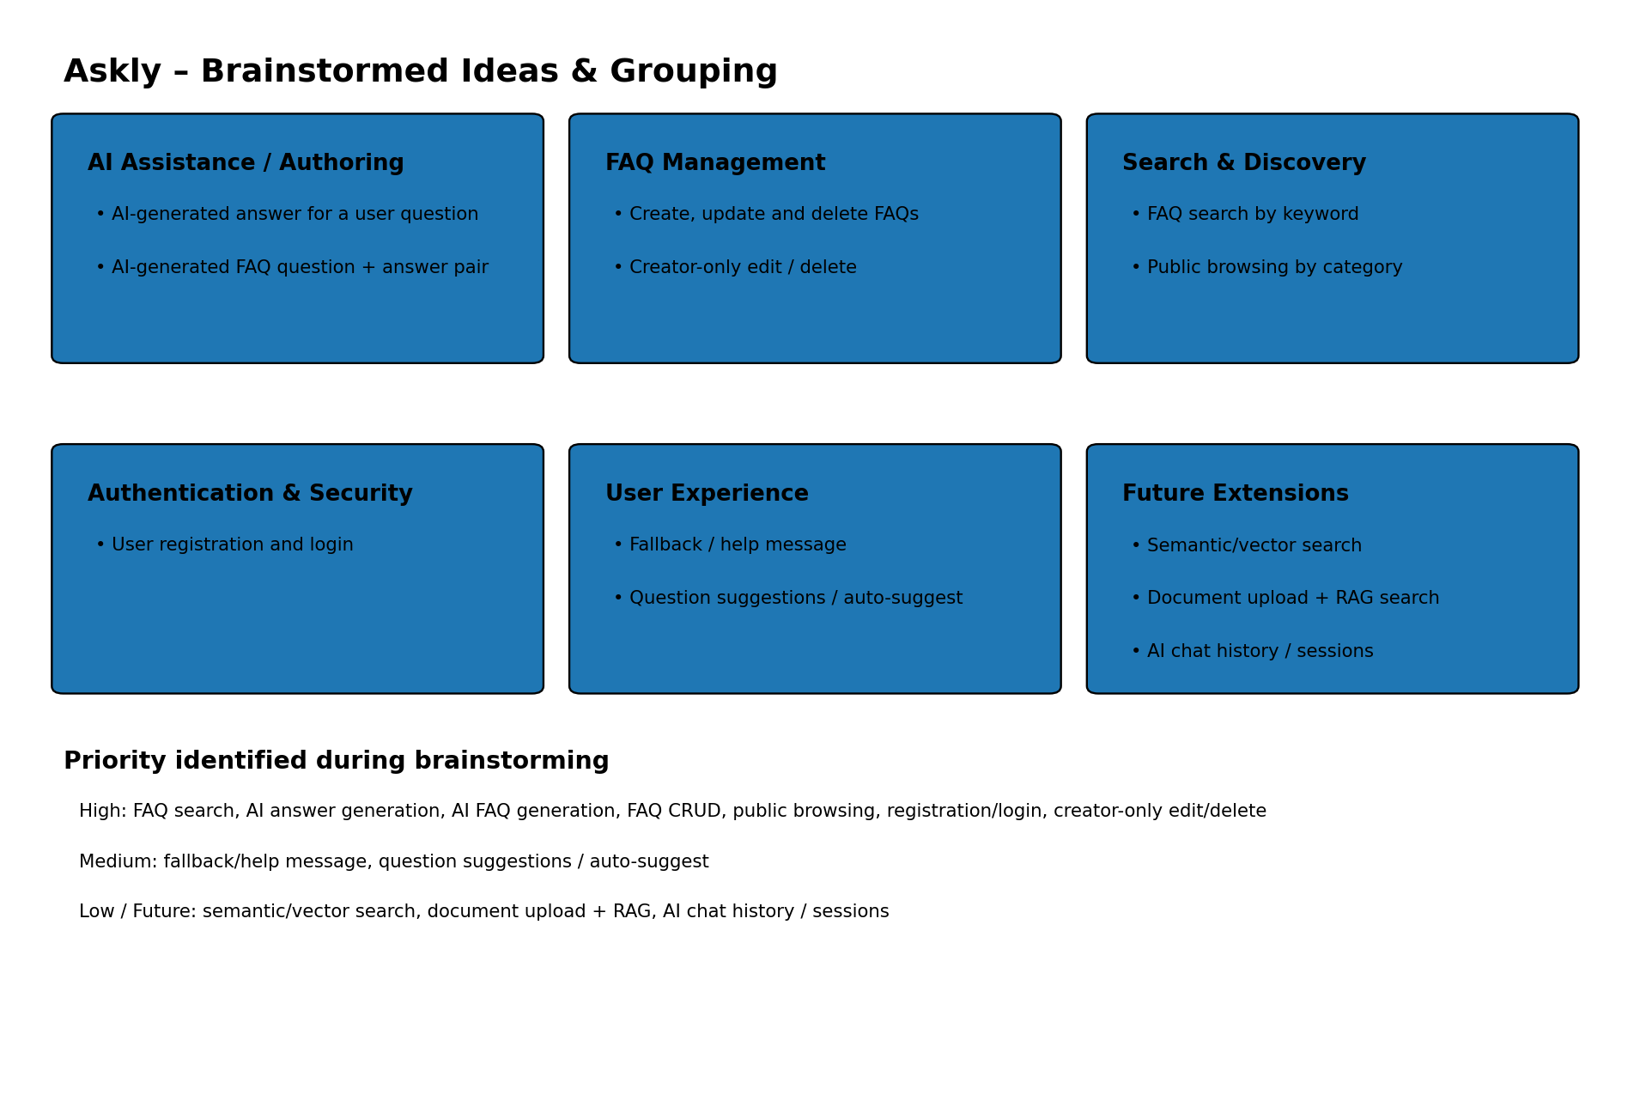

Step-3: Idea Prioritization
Prioritization was based on user value, relevance to the project, feasibility, and the current project scope. Future-extension ideas were kept lower because they are not part of the current implementation.
12. AI chat history / sessions — Low
11. Document upload and RAG search — Low
10. Semantic/vector search — Low
9. Fallback/help message — Medium
8. Question suggestions / auto-suggest — Medium
7. Creator-only edit and delete — High
6. User registration and login — High
5. Public FAQ browsing by category — High
4. Create, update and delete FAQs — High
3. FAQ search by keyword — High
2. AI-generated FAQ question and answer pair — High
1. AI-generated answer for a user question — High
Prioritized Ideas:
